Daniel DeCarlo

Box # 107

Cairn University School of Business

CIS122 Essentials of Networking

Project # 10

Project objective:

The objective of this project is to set up a wireless mesh network using a Wi-Fi adapter. The purpose of creating our own network is to give access to places where there isn’t WI-FI or we need a reliable and portable way of creating a network. A benefit of setting up the wireless mesh network, it allows us to provide a network security which helps protects the data and packets that are sent through the network. Another reason for setting up multiple mesh networks with the Wi-Fi adapter allows us to boost the signal, which allows us to gain access to the network over longer distances. In this project we will be installing the drivers on Windows.

Equipment used:

|  |  |  |  |  |
| --- | --- | --- | --- | --- |
| Equipment Description | Vendor | Vendor Item # | Retail price | Actual price (if known) |
| BrosTrend™ AC1200 WiFi USB Adapter  AC1 | Amazon | AC1 | $22.99 | https://www.amazon.com/BrosTrend-1200Mbps-Network-Adapter-AC1/dp/B01BV91L7Y/ref=sr_1_fkmrnull_1?keywords=BrosTrend+1200Mbps+USB+WiFi+Network+Adapter%3B+Dual+Band+AC+5GHz+WiFi+Speed+867Mbps%2C+2.4GHz+300Mbps%3B+for+Desktop%2C+Laptop%2C+PC+of+Windows+10%2C+Windows+8%2C+Windows+7%2FXP%3B+USB+3.0%3B+AC+1200+%28AC1+Model%29&qid=1556558627&s=gateway&sr=8-1-fkmrnull |
| BrosTrend AC1200 Drivers | BrosTrend | N/A | Free Download | https://www.trendtechcn.com/Product.aspx?ProductId=323&TypeId=2 |

Detailed list of software and operating platforms used, including version numbers and licensing requirements:

* Windows 10 / 8.1 / 8 / 7 / XP, 32/64 bit
* BrosTrend AC1200 Drivers (windows) **If running another OS use the specific driver for that OS**

Network diagram:

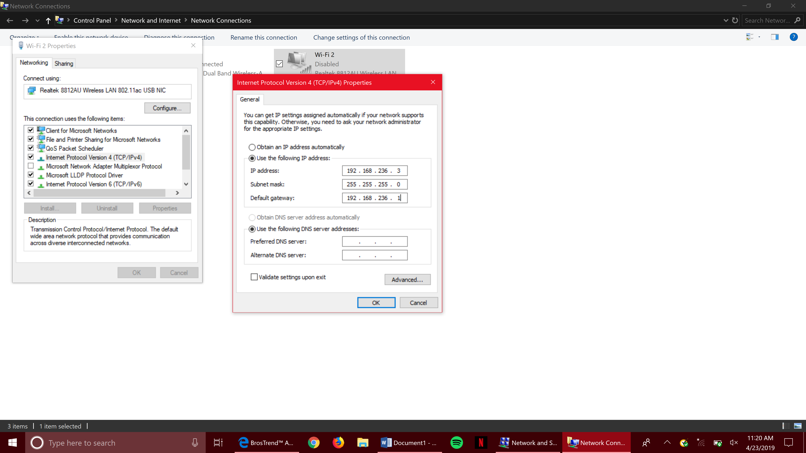

*this is what the properties look like when setting up the network*

Configurations:

1. Take the WI-FI adapter out of the packaging and plug in the device into the USB slot.
2. Next download the driver for the adapter on the following link:

<https://www.trendtechcn.com/Product.aspx?ProductId=323&TypeId=2>

1. Follow the prompts that appear on screen when the driver finished downloading.
2. Next, go to control Panel and go to Network and Sharing Center.
3. Then hit “Change advanced sharing settings” located on the left.
4. There should be different networks listed and among them should be the Wi-Fi adapter.
5. Then open command prompt and right click and there should appear different options. Click the option “run as administrator”.
6. Once command prompt opens use the command

netsh wlan set hostednetwork mode allow= ssid= key=

1. Before you click enter in the command prompt make sure you put an **ssid** name so that other adapters can connect to the device. Key is optional in this project.
2. When this is complete go back to the control panel network option and go to the network and click properties.
3. Click configure and then choose the ADHOC option and enable it. After enabling the ADHOC go back to the Wi-Fi adapter properties and choose properties.
4. When properties opens up put in the IP address 192.168.236.1 (the .1 on the end can change depending on the amount of adapters in use. If there are two adapters then the .1 would have to change to .2 to show that there is a second device.)
5. After this is complete enable the network by right clicking the network name in the control panel.
6. Enter the SSID and then there should be a connection.